PortaView Prototype Descriptions
By William Lee (wwlee1)
With Samantha Szymczak (sszymcza), Micah Noland (noland), and Forest Flodin (fflodin)

Basic Architecture
We have designed a paper-based prototype that covers the main idea and interaction paths for PortaView. Since PortaView is a distributed application, we first need to present the main concept for PortaView’s architecture:

Master PortaView Displayer (PVD) (contains all pictures)

PortaView Displayer (Kitchen)
PortaView
Displayer (Mom’s Bedroom)
PortaView
Displayer
(Dad’s Bedroom)
PortaView Manager (PVM)
Figure 1: PortaView Architecture
PortaView contains two main parts: PortaView Manager (PVM) and PortaView Displayer (PVD). In our implementation, only the master PortaView runs both programs. Theoretically, it should be possible that PVM runs on the other PortaViews also. If a PVM can be run on all the PortaViews, then users can change their pictures everywhere they go. It is out of scope for this project (see the Limitations section in the original PortaView proposal).

PortaView Manager Interface
The main PVM screen looks like the following:
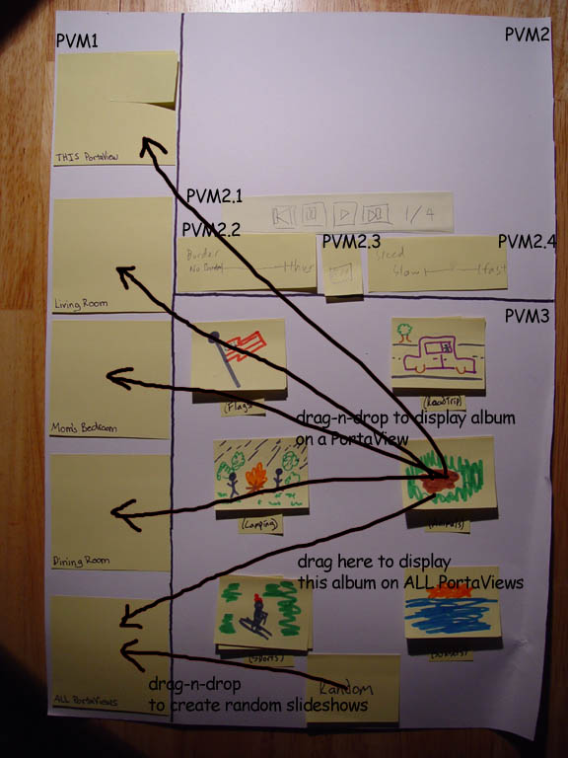
Figure 2: Main PVM View

PortaView Panel (PVM1)
When the users first turn on the master PortaView, they would see the PVM screen. If they turn on a non-master device, they would see the only the PVD. The left panel (PVM1) shows a list of PortaViews that are currently connected to the master device. In this project, we assume that the master PortaView has previously detected the others. Thus, the PVM would have a predetermined list of connected PortaViews.
Each icon displayed in PVM1 would show the current picture displayed on each PVD running on the local or remote machine. This view would periodically change from time to time, depending on the current view for the remote PVD. This gives immediate feedback to the user on what picture is currently displaying on the PVD. The labels beneath each icon in PVM1 would show the location and the name of the album that’s currently displaying. The icons would initially contain nothing, since there is no album currently displaying on the PVDs. If we drag a picture to an icon in PVM1, it would look like this (“this” PortaView refers to the PVD that’s running on the same machine as the PVM):
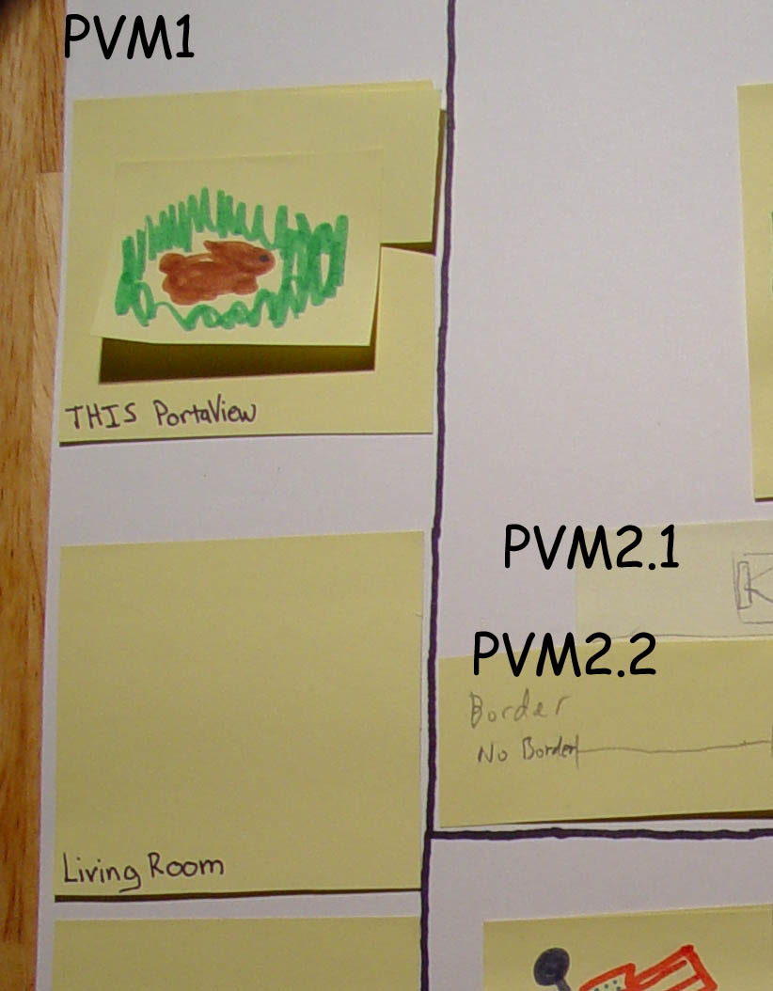
Figure 3: PortaViews
There is an “All PortaViews” icon on the bottom left of PVM1:
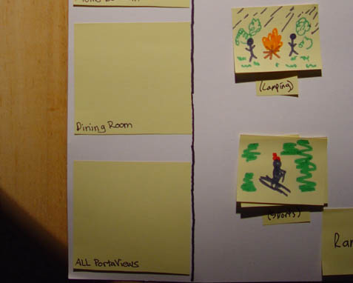
Figure 4: All PortaViews
This icon is used for simultaneously deploying albums on all the PortaViews. Later sections would clarify the use for this icon.

Preview Panel (PVM2)
This panel contains a preview of this picture currently showing on the selected PortaView. You can select a PortaView by clicking on the icon in PVM1. Selecting the “All PortaView” icon would have no effect. Here is an example of what PVM2 would look like if a PortaView is selected:

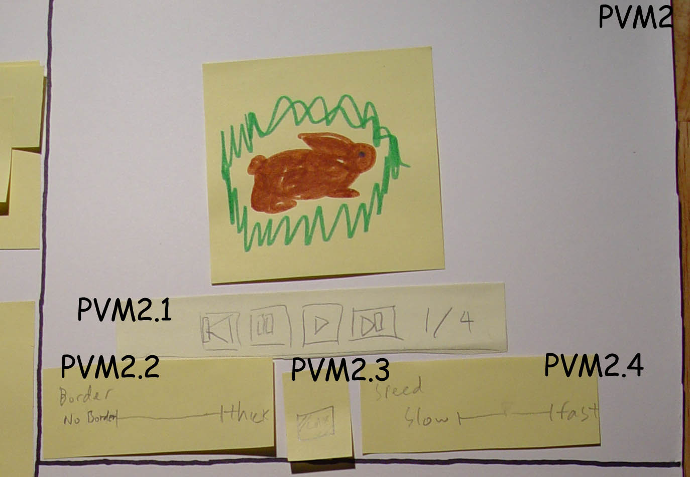
Figure 5: Preview Panel
In PVM2, the current image that the PortaView shows on its current PVD would be displayed in PVM2.1. There are 4 buttons that gives control for the image showing: previous, pause, play, and forward respectively. There is also an indicator that shows the number of the image that you are currently displaying on the PortaView selected. PVM’s state may disable or enable PVM2.1’s controls. For example, the previous button would be disabled if you are on the first image. The controls would be disabled if no PortaView is selected in PVM1, etc.
In PVM2.2, you have a frame border control. You can choose the border thickness by sliding left to right on the slider, and you can choose the desired color in PVM2.3. PVM2.2 and PVM2.3 would also be disabled according to the active state.
In PVM 2.4, there is a slider that controls the speed for playing the album. You can select from 1 minute (slow) to 2 seconds (fast).
Note that all controls within PVM2 would be automatically adjusted for the PortaView selected in PVM1. Therefore, all effects take place instantaneously.

Album Panel (PVM3)
We are not going to provide any utility for organizing the album, since that is out of our scope. We assume that all albums are organized underneath a repository folder (such as the “My Pictures” folders on Windows platforms). Albums are essentially subfolders, and albums contain only pictures, so there’s no subfolder under the albums. The folder names represent the albums’ names. The Album Panel (PVM3) looks like:
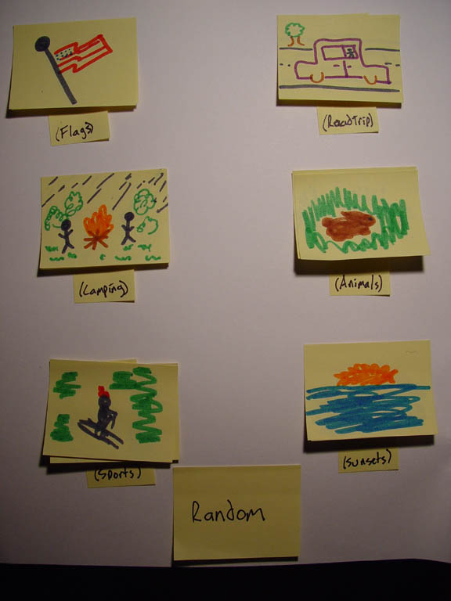
Figure 6: Album Panel
In PVM3, we show the content for all the albums in the repository. It is a scrollable pane. Each icon shows the first picture in the corresponding album folder. The name of the folder is displayed under each icon.
You can assign an album to a PortaView by dragging the album to the icon for the PortaView in PVM1. The album then would replace the PortaView’s previous album. At this time, a command is also sent to the remote PortaView’s PVD to refresh its content. This action would also trigger change in the Preview Panel (PVM2).
If you click on the album icon, such as PVM3.1, the Album Panel would display the content of the folder. There is a “Back” button on the upper left so you can get back to the Album View. The photo view looks like:
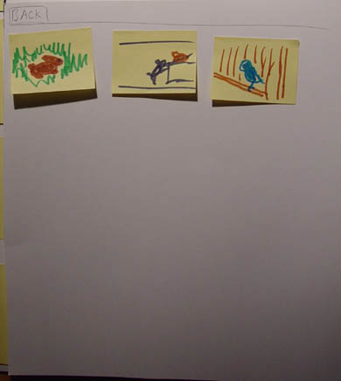
Figure 7: Inside Album
You can also drag individual pictures to the PortaView icons in PVM1. Dragging individual picture essentially means creating a slideshow of 1 picture.
There is a special “Random” icon in the album. If you drag this to any of the PortaView icons in PVM1, a random album would be selected for that PortaView. Dragging the Random album to the “All PortaViews” icon in PVM1 (see Figure 4) would randomly assign different albums to all PortaViews.

PortaView Displayer Interface
PVD is very simple. It usually contains a screen that displays the picture. It essentially looks like:
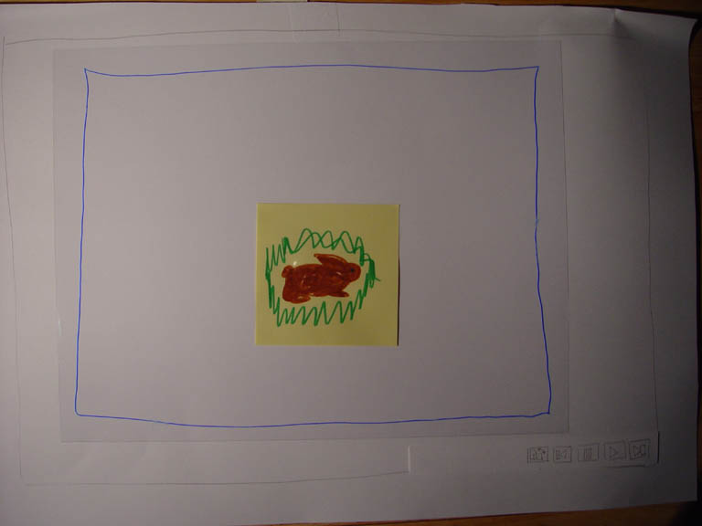
Figure 8: PortaView Displayer
On the lower right, there are different options for viewing the current pictures. This list of controls is similar to the controls in PVM2.2. There is a toolbar on the lower right:
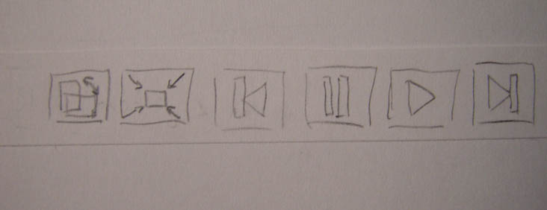
Figure 9: PVD Controls
From left to right, the buttons are: landscape/portrait, minimize (to show the PortaView Manager), and the standard play/pause buttons. The minimize button would not be enabled for non-master PortaViews. The landscape/portrait button would switch the view mode for PortaView, since sometimes you may want to use the portrait mode for PortaView. In portrait mode, the PVD looks like:
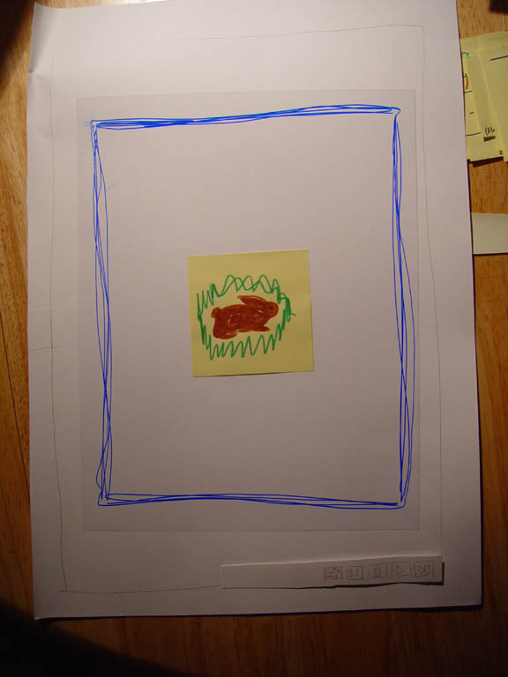
Figure 10: PVD In Portrait Mode
Note that the button bars would change its position also.

Tasks and Walkthroughs

Task 1
User wants to check what is displayed on the PortaView in Mom’s Bedroom and change the displayed picture to another.
- Click on the “Mom’s Bedroom” PortaView in PVM1
- Check what picture is displaying on the PortaView
- Click on an album icon in PVM3
- Search for the image you would like to display
- Drag the image to “Mom’s Bedroom” in PVM1

Task 2
User wants to display the animal pictures on the PortaView in Dad’s room, adds a green border of medium thickness to each picture, and modify the option to change slides once every 5 seconds.
- Click on the “Dad’s Bedroom” PortaView in PVM1
- Check what picture is displaying on the PortaView
- Drag the album that indicates “Animals” to “Dad’s Bedroom” in PVM1
- In PVM2, click on the color selection panel
- Pick the color from the color picker
- Hit Ok
- Change the slider in PVM2.3 to medium thickness
- Change the slider in PVM2.5 (speed control) to change slides every 5 seconds.

Task 3
User wants to display random albums for all the PortaViews
- Drag the Random album to the “All PortaViews” icon in PVM1

Task 4
When viewing the picture on a PortaView, user wants to stop on a particular picture.
- Click on the “Pause” button on a PVD
Or rather, he/she can:
- Open the Manager by clicking on the “Minimize” button on the PVD
- Click the “pause” button
- Click the “previous” or “next” button in PVM2.2 until the user finds the picture

